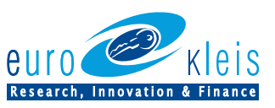

SUSTAINABILITY
REPORT
ESG REPORT 2021

Individual non-financial statement under Legislative Decree No. 254/2016

Table of contents
Letter to Stakeholders 4
1. Introduction 4
1.1. Eurokleis methodology approach 4
1.2. Stakeholders 5
1.4. Eurokleis ESG strategy 6
1.5. Materiality analysis 7
2. Environmental, Social and Governmental (ESG) 9
2.1. The Company and Governance 10
2.1.1. Company History 10
2.1.2. Services 10
2.1.3. Eurokleis Headquarters 11
2.1.4. Eurokleis Timeline 12
2.1.5. Corporate Governance 14
2.1.6. Shareholders and Board of Directors 14
2.1.7. Code of ethics 15
2.2. Environment 16
2.3. Social 20
2.3.1. Gender Equality Plan 20
3. Conclusion 27
Appendix 1 GRI Standards 29

Letter to Stakeholders
THIS PART SHOULD BE ADD A LETTER WRITTEN BY A SHAREHOLDER OR BOARD OF DIRECTOR

Introduction

Eurokleis methodology approach

Eurokleis has prepared the following Sustainability Report or Individual Non-Financial Statement (hereinafter also DNF) for 2022, in accordance with Articles 3 and 7 of Legislative Decree 254/2016 implementing Directive 2014/95/EU, to ensure maximum transparency to its stakeholders.
The scope of the Sustainability Reports is to identify and support the Environmental, Social, Governance relevant challenges by the materiality matrix analysis. Furthermore, describing how Eurokleis is creating impact for the interest to their internal and external stakeholders and works as a systematic team to improve ESG issues.
Eurokleis has reported the information cited in the GRI content index for the period from 1 January 2021 to 31 December 2021 with reference to the GRI Standards. The Sustainability Report is the first version released but will be an annual reporting period. The document contains the following information:
- ESG topics: Identify how ESG areas are strongly related to Sustainable Development Goals and which themes can be addressed in the materiality analysis.
- Materiality Analysis: Selection of the relevant themes for the stakeholders to achieve a better ESG impact.
- Gender Equality Plan: According to the EU Gender Equality Strategy 2020-2025 are the Union policies to pursue significant progress in gender-equal Europe. Eurokleis has prepared its own plan to contribute to a reduction of gender bias in the EK community.
- Commitments: Eurokleis long-term company commitments were established jointly with shareholder's and the management team for a greater continuous improvement for the firm.
In consideration of the voluntary nature of the adoption of this DNF, the authors declare no conflict of interest, and, the Company decided not to submit this document to the attestation of conformity by an independent auditing firm. The document was submitted for examination, evaluation, and approval to the Board of Directors. Eurokleis has developed the present document following the GRI index methodology approach.

Stakeholders
Eurokleis considers stakeholders of any physical or legal nature, who is actively involved in the company, and whom has a responsibility or interest in the success of the company. Our stakeholder analysis was done by screening the touch points of people whose activities within the company influence the company's performance and decisions. The Sustainable Report has been prepared for the interest of our stakeholders to ensure transparency and integrate a vision to achieve the economic, environmental and social objectives. The following Fig. 1 shows Eurokleis main stakeholders.
Figure 1. Eurokleis Stakeholders
  - Our ESG approach
The necessity of integrating ESG into the business is of high priority for Eurokleis because we are interested by making positive changes in our company that reflects impact in our environment and community. As a consultant company, we decided to do a materiality study to focus reporting on ESG topics that are significant in relation to our activities and our stakeholders, delimiting our social responsibility in relation with ESG topics and Sustainable Development Goals (SDG).
The board of directors supports the ESG and is committed to increasing openness for all stakeholders, including our clients, employees, and partners. The correlation of ESG topics with the Sustainable Development Goals (SDG) is significant to build a growth plan and contribute with activities that would have a longer-term influence on our business, and due to Eurokleis capabilities we are focused on eight SDGs to contribute to growth, sustainability, and inclusion:
Table 1. Eurokleis SDGs
Sustainability |  | Eurokleis Commitments Sustainable Development Goals 2022
 | 12 - Consumption and protection | - Reduce plastic usage  - Reduce paper usage
 | 13 - Climate Action | - A 100% use of recycled paper or FSC paper  - Increase use of green sources energy  - Increase of Cloud instruments that impact the power and less paper us.  - Reduce CO2 Emissions
Inclusion
 | 5 – Gender Equality | - Consolidate the gender equality plan
 | 10 – Reduced Inequalities | - Ensure equal opportunities and end discrimination
Growth
 | 4 - Quality of Education | - Support domestic technology development and industrial diversification
 | 8 - Decent work and economic Growth | - Support domestic technology development and industrial diversification
 | 9 - Industry innovation and infrastructure | - Universal access to information and communications technology

Eurokleis ESG strategy

Eurokleis Background
Eurokleis has expertise to shape business, society and the environment. The collaboration of research in deep tech, market analysis and trends has sought to generate articles and projects that can inspire actions for a greater impact assessment since the
The collaboration with our partners has been seeded for the development of the following projects on a national and international scale.
2021 Highlights
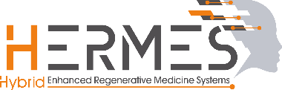 | Funding Scheme: RIA – Research and Innovation Action  Call for Proposal: H2020-FETPROACT-2018-01  Partner Country : IT ES DK GB FN BE  Duration: 2019-2023  Site hermes-fet.eu
Funding Scheme: Creative Europe
Call for Proposal:
Partner Country: UK, IT, BE, ES, IR, GE, GR, HU, RO, DK, PL
Duration: 2022 - 2024
Site: https://www.futures-photography.com/

How Eurokleis is impacting ESG topics as a business consultancy company?
There are regulatory reforms that have led to an increase in consulting services such as the EU General Data Protection Regulation, Sustainable reforms and other types of demands to stay compliant with regulations that show transparency for stakeholders.
The Global consultancy service is growing in Europe specially for management and financial consulting services. Recently digital consulting is one of the biggest drives of growth, using data for reducing cost, increasing efficiency and attracting more audiences.
According to the most recent report by the (European Federation of Management Consultancies Associations (FEACO) only 11 European countries represent 8% of the workforce for consulting services and are expected to have a turnover growth of 10% rate for 2022.
Eurokleis is creating economic and financial value for Companies ideas growth, projects but most important the business of our clients.

Materiality analysis
Materiality analysis is the key process behind the preparation of the Sustainability Report, and aims to select the "material" economic, environmental and social issues that are more significant for Eurokleis and its stakeholders. The materiality analysis was performed with a questionnaire that was delivered via email. The following Table 2 shows the twenty-two selected ESG topics divided by Governance, Social and Environmental subjects.

Table 2. ESG Topics
ESG Topics
Economic and Governance
1 | Creation of economic and financial value
2 | Corporate welfare
3 | Governance and transparent conduct
4 | Ethics and business integrity
5 | Risk management and ability to react to changes
6 | Integration of aspects of ESG standards into the company's strategy
7 | Responsible innovation and digital transformation
8 | Privacy and data security
Social
9 | Inclusion and diversity
10 | Recruitment, training and skills development
11 | Employee well-being
12 | Sustainable supply chain
13 | Human rights
14 | The impact of activities on the customer
15 | Brand reputation
16 | Relationship and dialogue with Stakeholders
17 | Support and development to the community
Environmental
18 | Energy efficiency
19 | Attention to the use of resources
20 | Climate change and emissions
21 | ICT solutions for sustainable development
22 | Environmental protection

Eurokleis understand that all topics are important, and strategies must be developed to have positive impacts. The company would like to integrate the opinion of our stakeholders for providing a degree of involvement to cooperate and focus our activities on these objectives.
The result of the materiality analysis shows the relevance scale from higher to lowest priority (Figure 2). The following survey results shows that Governance topics are more relevant rather than Social and Environmental ones (explain why). In first place, Eurokleis stakeholders considered creating value for the market and have risk management ability to react to any changes as a priority.

Secondly social concern such as brand reputation and the interest to be more inclusive and diverse depend on the measures that could be involved in the Gender Equality Plan.

Eurokleis has a lower focus on environmental topics because the participation on this topic is more related on individual daily activities to have responsibility to protect the environment. But as a team we are able to have positive impact on ICT solutions for sustainable concerns such as recycling, CO2 measurement to raise awareness inside or outside the organisation.

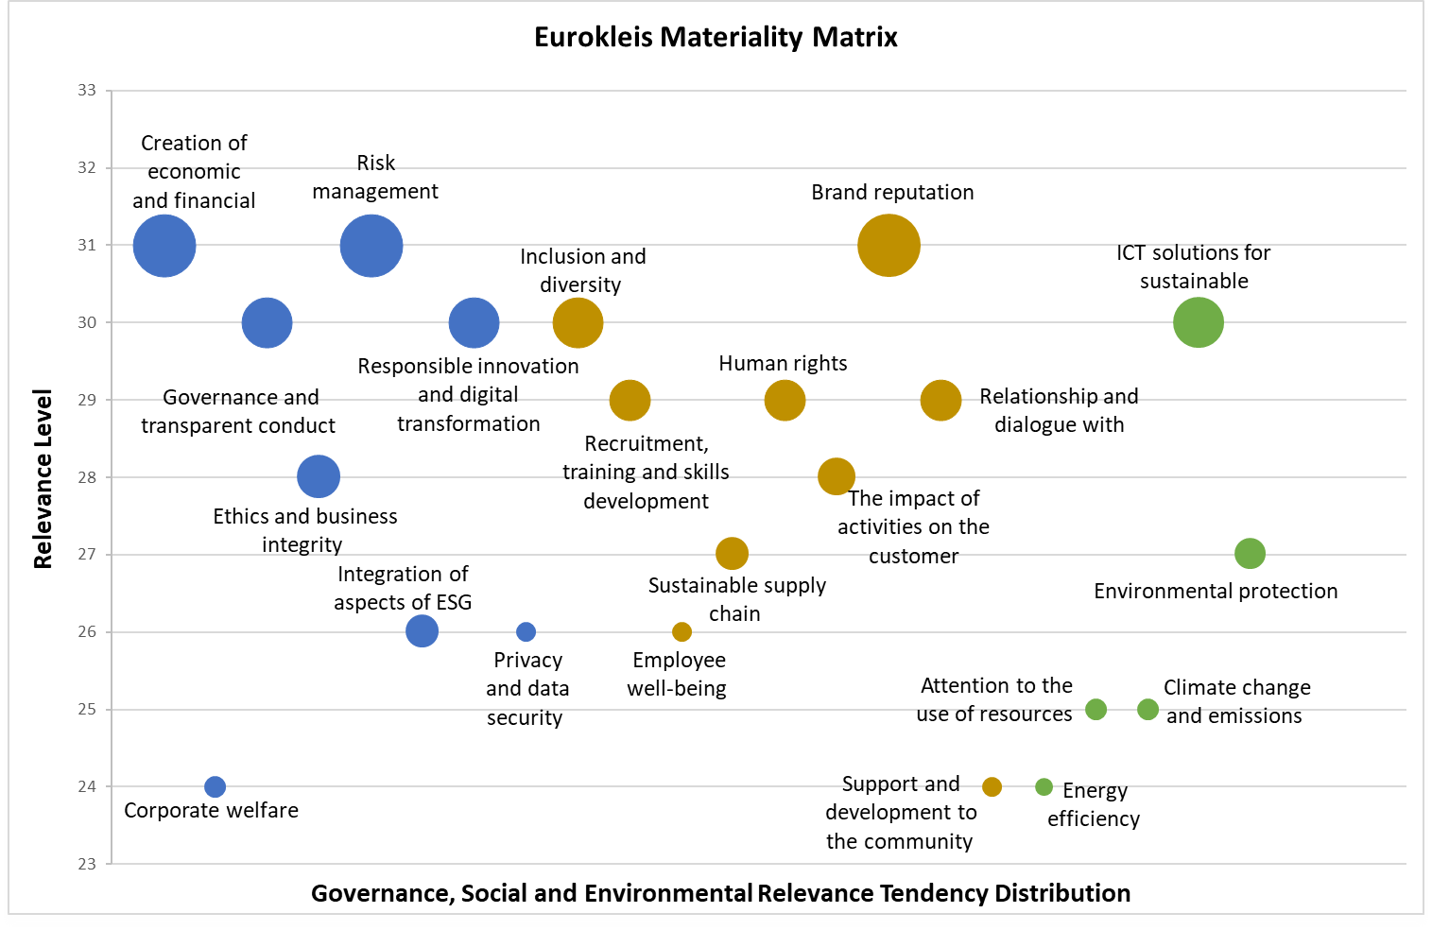
Fig. Materiality Matrix: Relevance Level of ESG Topics by Eurokleis Stakeholders

Environmental, Social and Governmental (ESG)

The Company and Governance

Company History
Eurokleis is legally constituted as a limited liability company (S.R.L), it was founded in 2000 as an academic spin-off that brings together economic, technological, business and legal competencies and offers advisory in all business fields with special attention to innovative enterprises providing its knowledge in applied research and integrates different and flexible expertise to the companies of all natures. Eurokleis S.R.L. provides its products/services in the following 6 key pillars in business development:
- Start: Your idea becomes business
- Grow: We support the change and sustainability of your business.
- Innovate: Design and emerge your business to stand out on the market.
- Comply
- Tax & Legal: Minimize risks and exploit your potential.
- Research: Long experience in the field of applied research and collaboration for projects funded for the European Union and National.
- Learn: Training courses, dissemination, publications and knowledge transfer enable benefits for our clients.
The synergy and integration of the various services allow us to create value and optimize business performance throughout the life cycle of the company.
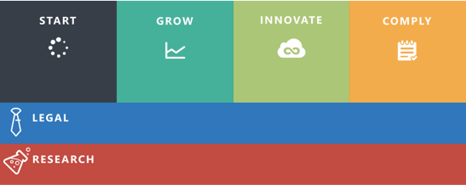
Figure 3. Eurokleis Six Pillars

Services
Eurokleis is a consultancy company that offer personalize services depending on the demand of each client but also offer predefined services for vary business lifecycle phases. The following figure shows the services we offer and on which we have experience.
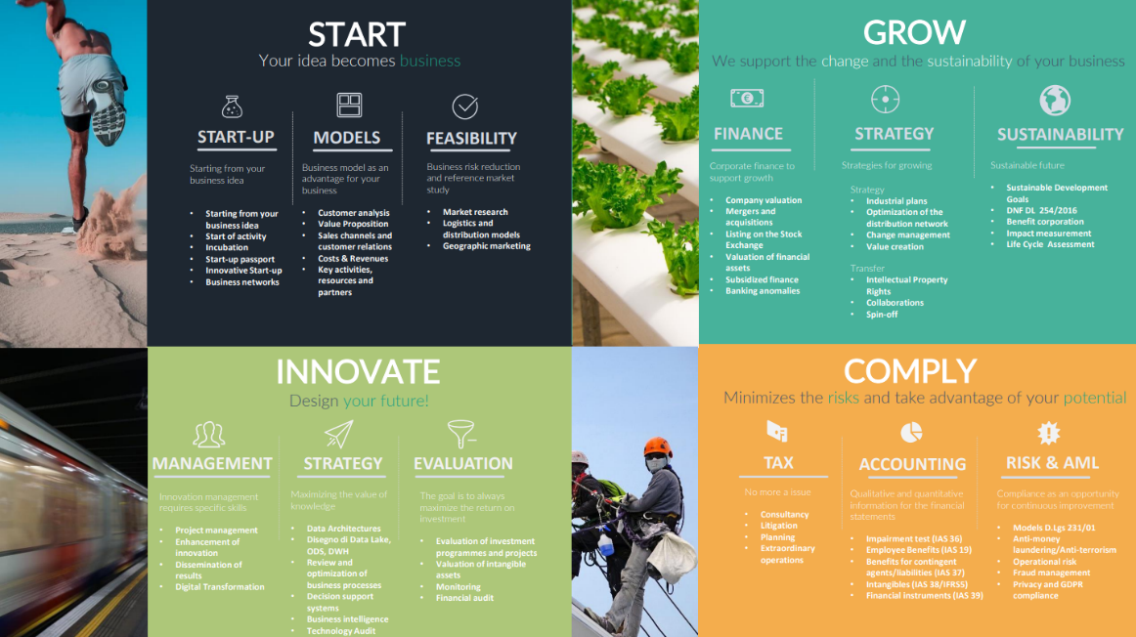
Figure 4. Eurokleis Services

Eurokleis Headquarters
Eurokleis is an Italian consultancy company located in two key cities in the country. The principal office is located in Rome (Via Romeo Romei, 27, 00136 Roma) and the second in Milan (Via dei Piatti, 11, 20123 Milano). Eurokleis welcomes visitors from Monday to Friday: 9.00 -18.30, it is also open to being contacted regarding the report through email info@eurokleis or by phone (+39) 06 44254074.
Eurokleis Profile
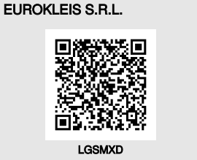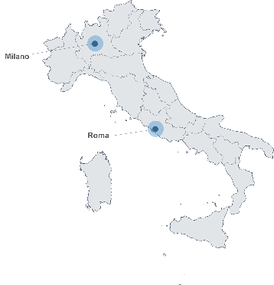  Figure 5. Eurokleis presence in Italy | Legal Address | Via Romeo Romei, 27, 00136 Roma
 | PEC Address | eurokleis@pec.it
 | Telephone | 06 442 54074
 | Website | www.eurokleis.com
 | E-mail | info@eurokleis.com
 | REA Number | RM-946886
 | VAT Number | 06077951009
 | Legal Form | Società a responsabilità limitata
 | Constitution Date | 10/04/2000
 | Inscription Date | 30/05/2000
 | Last protocol Date | 30/06/2021

Eurokleis Timeline

Eurokleis's history started more than 20 years ago, working for a continuous improvement-oriented towards innovation. Boosting companies and projects which has a positive impact on the environment, society and government. Eurokleis offers strong expertise in Research projects with 15 years of experience and doing more than 15 European Research Projects. The table below reminds a past of joint collaboration with our stakeholders as a promising expression of a company with the purpose of a positive change.
1998 | Francesco, Luca e Antonio met in an International Conference of programming language.
2000 | The 3 founding partners decided to start a new business together.
2003 | Inspired by greek κλείς (kleís) meaning key, the name of Eurokleis is chosen as "The Key to Europe"
2008 | EU Projects EACEA e Erina
2010 | EU Project Sequoia
2010 | EU Project Erina+
2011 | EU Projects TrendMiner e e-Leilas
2012 | EU Project Metpex
2013 | EU Projects IA4SI e Maxiculture
2014 | Participation in business networks Nemesys e Pro.CID.A.
2014 | Consortium of Digital Regions  http://www.regionidigitali.eu
2014 | EU Project JamToday
2016 | EU Projects I3 e Suits
2017 | EU Project Hyper360
2018 | EU Project HERMES
2019 | The second office in opens in Milan
2020 | Accredited as an Innovative SME
2020 | Use Case ESBLINK
2020 | Use Case THE MUSH! Company

Corporate Governance

Eurokleis Corporate Governance pursues a determination and adherence to principles with healthy market practices by cooperating with the internal norms and rules but also with external requirements that the capital market imposed.
The company management and the board of directors are jointly strengthening trust between by having a consolidated Corporate Governance. The main relevance of Eurokleis Governance is guaranteeing transparency and responsibility activities towards third parties, employees, collaborators, shareholders and the market in general, with a view to pursuing a greater social responsibility and pursuing our ESG objectives.

Shareholders and Board of Directors

A summary of the corporate composition and of the other holders of rights on shares and quotas is represented on the next figures.
Shareholders
Three main shareholders constitute the capital of Eurokleis. Francesco Bellini is the largest investor, contributing 45 percent of the total capital, while Luca Satolli and Antonio Annibali each contribute 27.5 percent of the remaining 55 percent. (See figure)
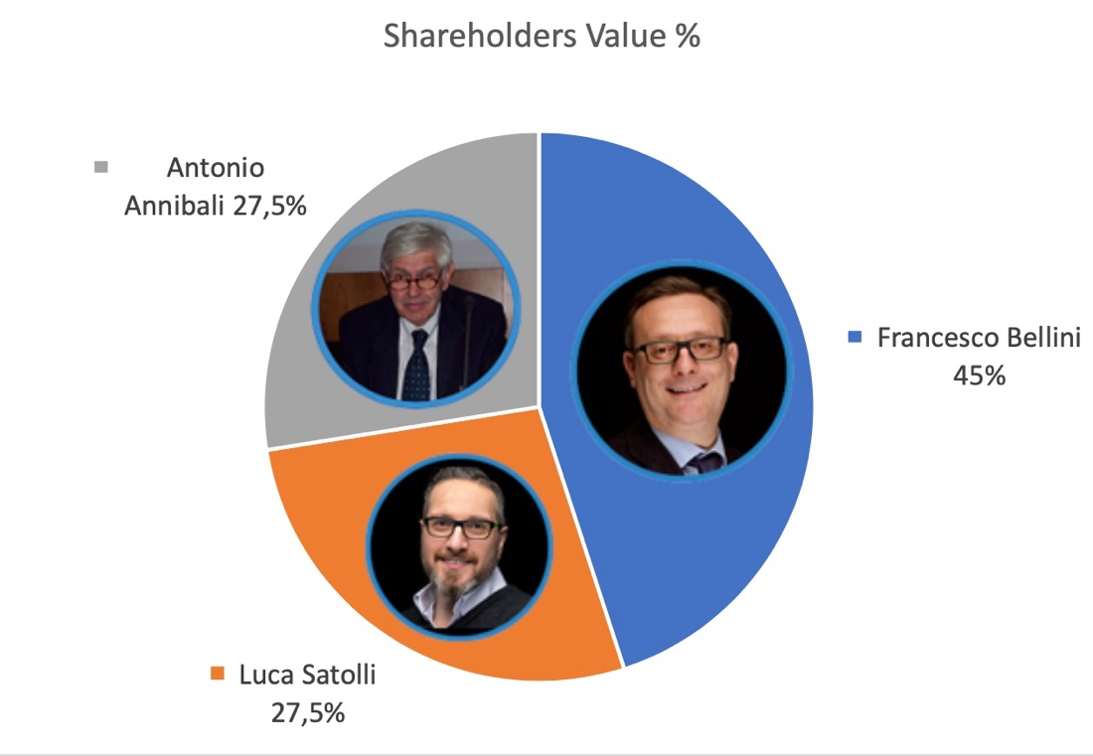
Fig. Eurokleis Capital Distribution

Board of Directors
The current Board of Directors is constituted of 3 members; our Chairwoman Giorgia Fiume and Advisors Luca Satolli and Antonio Annibali. The initial date of their charge was 29/04/2021, which is for an unlimited term.
The decision-making is balanced among the Board of Directors, this is the beginning of a Gender Balance and leadership decision example, supporting each other as an element to unified information, mission command, motivation, sustainment and direction to accomplish the mission and improve the organization. Communication effectiveness has been a key to achieving a balance between Eurokleis Leadership.
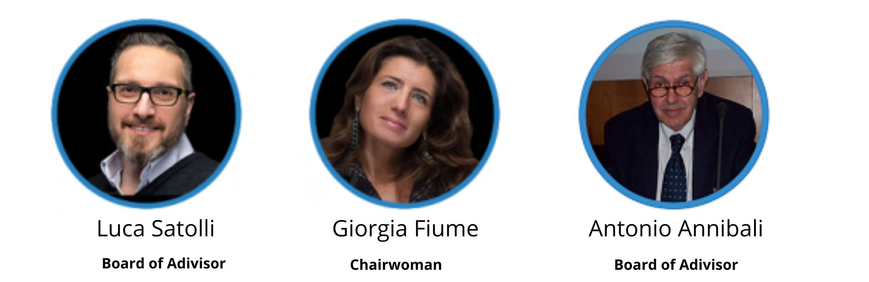
Fig. Board of Directors

Code of ethics

Eurokleis S.R.L. activates an Ethical Codes in the realization of the social purpose, proposing and implementing projects, actions and investments useful for increasing intellectual capital, management and technological values and long-term well-being for employees and the community.
The Code of Ethics represents the "charter of fundamental rights and duties" through which an organization clarifies its ethical and social responsibilities towards the various internal and external "stakeholders", seeking forms of balance and / or points of balance between the multiple interests and legitimate claims made by them.
The primary objective of a Code of Ethics is to make explicit a system of values and rules of conduct for the achievement of the company mission that, when shared, acts as a glue, reinforces the identity inside and transmits it to the outside.
It contains principles and rules of conduct through which the company's decision-making processes are implemented and oriented.
It is, ultimately, an instrument of governance of relations between the company and the outside, of strategic management, as well as of personnel discipline.
The functions attributed to a Code of Ethics are essentially two:
- incentive, since it generates a boost to the observance of rules on which the formation of the company's reputation and fiduciary relationships depend;
- of a cognitive nature, since through the enunciation of principles and rules it is possible to recognize unethical behaviours and, consequently, clarify the appropriate exercise of the authority, delegation, discretion and decision-making autonomy of each individual concerned, inside and outside the organization.
Our code of ethics is breakdown into 5 Articles as follows:
ART.1 Reference Principles
ART. 2 Impartiality
ART. 3 Confidentiality
ART. 4 Operating behaviour in service
ART. 5 Gift and other utilities
Note: For further consultation visit www.eurokleis.com

Environment
Eurokleis is supporting the efforts for green energy power resources and the reduction for energy consumed within the organization. The electricity in Italy has been a proceeded modernization and development of the electrical network. In 2001 the introduction of smart meters allows the user to pay for electricity depending on time slots divided into F1, F2, F3.
Table 3. Italian Energy Time Slots
Hour | Monday-Friday | Saturday | Sunday & Holidays
7:00-8:00 | F2 | F2 | F3
8:00-19:00 | F1 | F2 | F3
19:00-23:00 | F2 | F2 | F3
23:00-7:00 | F3 | F3 | F3

Note:
F1 | Expensive
F2 | Moreles
F3 | Less expensive

Our main supplier for energy is Enel an Italian establishment since 1962. According to the most recent Enel bill the energy produced in 2020 came from the following Composition of the energy mix:
Table. Enel sources of energy production in 2020
Energy sources | 2020
Renewable sources | 38.08%
Carbon | 8.31%
Natural Gas | 45.73%
Petroleum Products | 0.53%
Nuclear | 3.61%
Other sources | 3.28%

The electricity price is established in € / kWh (euros per kilowatt-hour) and the negotiable price per kWh can vary from one supplier to another depending on the agreement. Eurokleis count with an "E-Light Luce Impresa" contract, the bill is bimestrial. It is important to note that Eurokleis has a stablished price for all time slots. This means that in 2021 from January to December the fixed price per kWh was 0.077000 €/kWh.
The Eurokleis electricity bill is frequently composed of a number of that can be categorized into four main groups. The following graph illustrates the approximate percentage for each category that makes up a Eurokleis Bills:
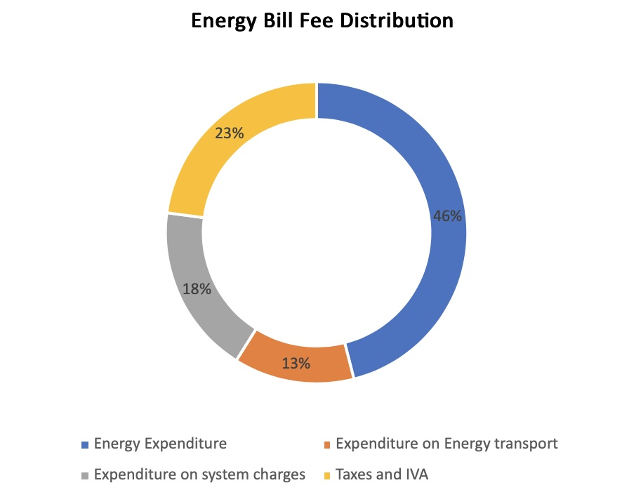
Fig. Eurokleis frequently energy bill fee distribution in %.
- Energy Expenditure: It is cost of electricity composed by energy mono and other expenditures.
- Expenditure on Energy transport: It is are the expenses for those who deal with the management of transport infrastructures (ARETI) and distribution and metering, such as local distributors.
- Expenditure on system charges: It is the sum of different components such as the expense for bonuses, incentives, etc.
- Taxes that include both VAT and excise duties.
Eurokleis Energy Consumption Analysis from Rome office
Considering that Eurokleis has a fixed price for timeslots the bills nevertheless it is informed the consumption by timeslots. Eurokleis is more likely to consume energy on F1 Time slots equivalent to 48% of the annual energy consumption compared with F2 (16%) and F3 (23%). This is due to the opening hours are Monday to Friday from 9:00 am to 7:00 pm. Furthermore, there are two months with higher-than-average energy consumption such as July and December, the reason for higher energy used is for climatizing the state of the office due to weather conditions during summer and winter.
Energy prices between 2020 and 2021 have increased by 0.0065 €/kWh from 0.070500 €/kWh to 0.077 €/kWh, even though the Russian war breakdown in 2022 the price raised slightly from 2021-2022 by 0.084€/kWh but has been steady since then.
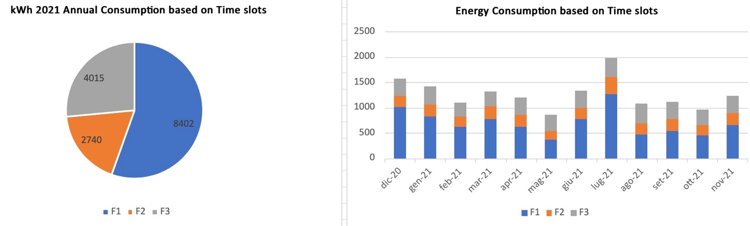
Figure. Eurokleis Rome Office Time Slots Consumption in 2021
For the latest information, Eurokleis consumed a total of 19,192 kWh from December 2020 to January 2022. The effective energy used was 17,412 kWh the rest of 1780 kWh (9%) represents energy lost. Grid losses are the energy losses that happen when electricity is produced and distributed. A portion of the energy generated is lost and does not reach its destination.
The energy loss represents a cost to the environment. Also, energy loss is charged to the company and it is taxable (136.80€+ VAT). The table below shows the energy consumed by Eurokleis plus the energy loss per month. Notice that there was a reduction from Dec 2020 to Dec 2021 and from Jan 2021- Jan 2022.
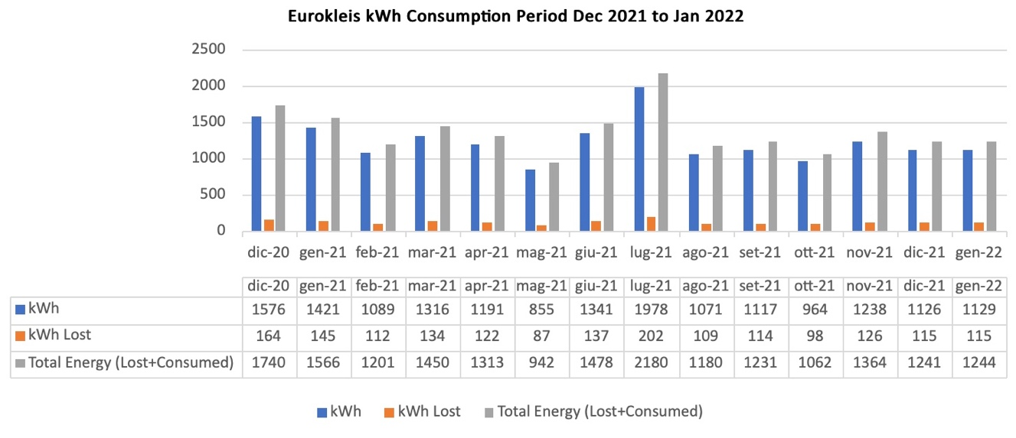
Fig. Eurokleis Rome Office kwh consumption from December 2021 to January 2022 period.
In 2021, Rome office had an annual bill cost reaching 4.482 € where 1.026 € accounts for VAT and other taxes. On the other side, it also receives benefits from government bonuses. Eurokleis was except to pay “system charges” from October 2021 to January 2022.
Eurokleis Energy Consumption Analysis from Milan office
Eurokleis consumed 580 kWh for the annual year 2021. Mainly in the timeslot of F1 (47%) rather than F2 (21%) and F3 (32%). The consumption in Milan was relatively low than the Rome office. In Milan, the bimestrial consumption average was 82 kWh and the months with more consumption were on December 2020 and May 2021.

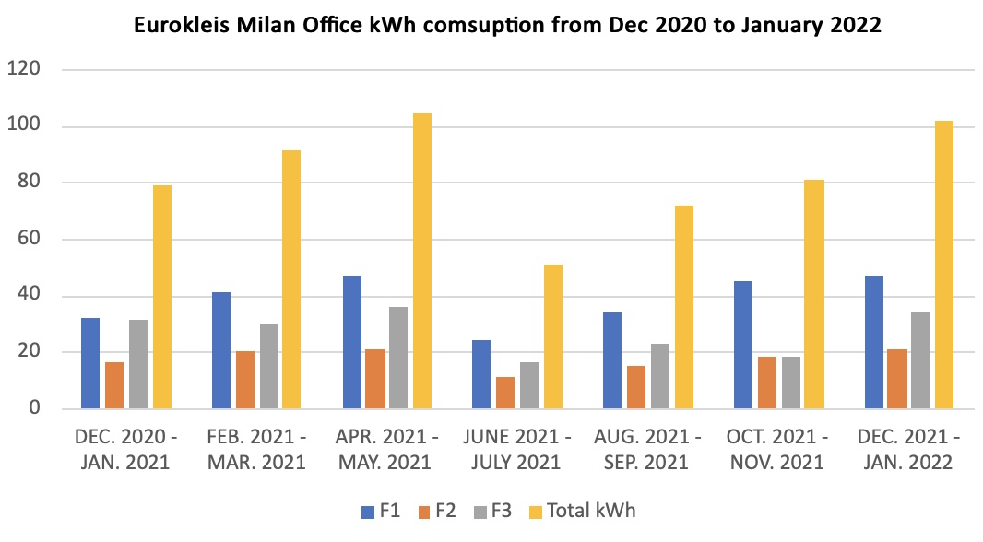
Fig. Eurokleis Milan Office kWh Consumption from December 2020 to January 2022 period.
CO2 Emissions
Eurokleis join the Schneider Electric initiative by using their digital tools to quantify CO2 emission. In 2021, according to Schneider database per kilowatt-hour (kWh) consumed is produced .388 grams of carbon dioxide (gCO2/kWh). This means that Eurokleis Rome office emitted 7,446.49 gr of CO2 from the consumption of 19,192 kWh from December 2020 to January 2022 while from Milan office emitted 225.04 gr of CO2 for 580 kWh consumed.
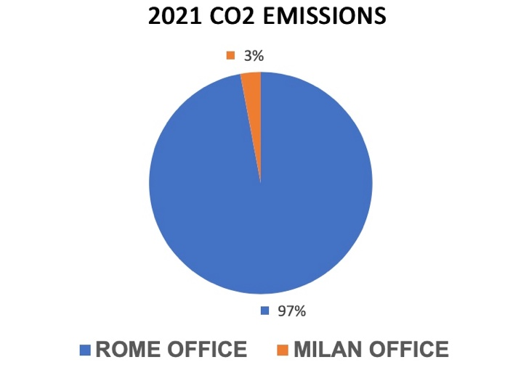
Fig.CO2 Emissions distribution in 2021 from Rome and Milan offices

How Eurokleis are making effort to reduce their consumption?
Eurokleis wants to minimise energy usage by raising awareness through internal communication and by exploring alternatives to traditional green energy sources. The acquisition of a micro wind generator for the Milan office is a good option because it can generate the kW that the firm requires yearly.
On the other side, with the office in Rome, the 6KW micro wind turbine must be able to produce 1243.72 kWh while also offering a 6-kW power-drawn performance. In 2021, the Rome office's highest requested power was 6.6 kW in July, while the lowest was 2.5 kW in October. We are looking forward to having positive changes by 2023 and we are considering a micro wind turbine a possible alternative.

Social

Gender Equality Plan

The Gender Equality Plan (GEP) is a fundamental action of Gender Balance and Inclusion that Eurokleis aims to promote throughout the company such as Research, Innovation, and Training.
Eurokleis (EK) aims towards promoting the development of early-stage professionals both female and male. Particularly for women who are more likely to be driven to interrupt or abandon their careers. EK provide opportunities to support a woman with equal decision-making power, and parental leave and incorporate them into several positions inside the company. Boosting life-work balance with time arrangements, motivating collaborators to incorporate any healthy habit into their agenda. Also, EK aims to incorporate the sex/gender dimension through all research and projects, being a diversity-based employer regardless of ethnicity or race and taking into account the different points of view as well as distinct pathways of work across activities. EK would build zero-tolerance workplace violence.
Eurokleis GEP includes actions to reach this objective across the forecast 2022-2027 period, monitoring annually the performance of EK and reinforcing the importance of the integration of GEP. The overall structure of GEP was built considering the Key Areas (KA) of the Horizon Europe GEP eligibility criterion.
Key Areas | Objectives |  |  |  | Actions |  | Direct Target |  |  |  |  | Indirect Target |  |  | Timeline |  |  |  |  |  |  |  |  |  |  |  |  |  | Responsible |  |  | KIs |  |  | Connection with GRI standards
 |  |  |  |  |  |  |  |  |  |  |  |  |  |  | 2022 |  | 2023 |  |  | 2024 |  |  | 2025 |  |  | 2026
KA1. Work-Life Balance and Organizational culture | 1.1 Promoting the creation of the activities plan that would support the Gender Equality Plan objectives. |  |  |  | Monitoring and ensure that activities in the workplace are displayed and respect the GEP. |  | Board of directors, administrative, collaborators and staff with motivation in the gender equality. |  |  |  |  | Stakeholders and Consortium partners |  |  |  |  | x |  |  | x |  |  | x |  |  | x |  |  | GEP Project Manager |  |  | Publication of the Plan in our website |  |  | 405-1  Diversity in governing bodies and among employees
KA1. Work-Life Balance and Organizational culture | 1.2 Flexible time arrangements for balance work and personal life |  |  |  | Availability to organize work schedules to foster a better planning from part-time to remote working. |  | Administrative, collaborators and staff with motivation in the gender equality. |  |  |  |  | Families of Eurokleis personnel |  |  |  |  | x |  |  | x |  |  | x |  |  | x |  |  | Board of directors |  |  | Annual countability of permissions given for flexible time by type of arrangement. |  |  | 401-2 Benefits for full-time employees, but not for part-time or fixed-term employees
KA1. Work-Life Balance and Organizational culture | 1.3 Parental leaving permissions |  |  |  | Feasibility for men and woman to take parental leaves. |  | Administrative, collaborators and staff with motivation in the gender equality. |  |  |  |  | Children of Eurokleis personnel |  |  | x |  | x |  |  | x |  |  | x |  |  | x |  |  | Board of directors |  |  | Annual countability of parental leaves |  |  | 401-3 Parental leave
Key Areas |  |  | Objectives | Actions |  |  | Direct Target |  |  | Indirect Target |  |  | Timeline |  |  |  |  |  |  |  |  |  |  |  |  |  |  | Responsible |  |  | KIs |  |  |  |  | Connection with GRI standards
 |  |  |  |  |  |  |  |  |  |  |  |  | 2022 |  |  | 2023 |  |  | 2024 |  |  | 2025 |  |  | 2026
KA2. Gender Balance in leadership and decision making |  |  | 2.1 Equal decision-making power. | Reinforce consciousness of selection biases. |  |  | Administrative, collaborators and staff. |  |  | Clients and Partners |  |  | x |  |  | x |  |  | x |  |  | x |  |  | x |  |  | Board of directors |  |  | No countable but offer more decision power in the coordination of own project. |  |  |  |  | 405-1  Diversity in governing bodies and among employees
KA2. Gender Balance in leadership and decision making |  |  | 2.2 Promoting the development of early-stage professionals both female and male. | Increase accountability and offer balanced workload activities. |  |  | New recruited staff and Interns |  |  | Administrative, collaborators and staff. |  |  | x |  |  | x |  |  | x |  |  | x |  |  |  |  |  | Project Supervisors |  |  | Annual countability of trainees in the company. |  |  |  |  | 404-1 Average hours of annual training per employee
KA2. Gender Balance in leadership and decision making |  |  | 2.3 Making committee membership more transparent. | Institutional recognition of all positions in the company. |  |  | Board of directors, administrative, collaborators and staff. |  |  | Stakeholders, Clients and Partners |  |  | x |  |  |  |  |  |  |  |  |  |  |  |  |  |  | IT and Communication personnel |  |  | Update team information in our website and introduce every new member. |  |  |  |  | 405-1  Diversity in governing bodies and among employees
Key Areas |  | Objectives |  |  |  | Measures |  | Direct Target |  |  | Indirect Target |  |  | Timeline |  |  |  |  |  |  |  |  |  |  |  |  |  |  | Responsible |  |  | KIs | Connection with GRI standards
 |  |  |  |  |  |  |  |  |  |  |  |  |  | 2022 |  |  | 2023 |  |  | 2024 |  |  | 2025 |  |  | 2026
KA3.Gender Equality in recruitment and Career Progression |  | 3.1 Diversity-based employer regardless of ethnicity or race. |  |  |  | Open job opportunities for foreign collaborators with equal benefits. |  | Board of directors, administrative personnel |  |  | Candidates |  |  | x |  |  | x |  |  | x |  |  | x |  |  | x |  |  | GEP Project Manager, administrative personnel |  |  | Annual countability of ethnicity or race diversity in EK team | 405-1  Diversity in governing bodies and among employees
KA3.Gender Equality in recruitment and Career Progression |  | 3.2 Promote courses to favour career opportunities. |  |  |  | Introduce advance training of courses in all levels for career progression. |  | All EK Personnel |  |  | Candidates |  |  | x |  |  | x |  |  | x |  |  | x |  |  | x |  |  | GEP Project Manager, administrative personnel |  |  | Annual countability of hrs of training by subject | 404-1 Average hours of annual training per employee
KA3.Gender Equality in recruitment and Career Progression |  | 3.3 Incorporate a minimum number of women into several positions inside the company. |  |  |  | Ensure that woman positions are well recognised. |  | All EK Personnel |  |  | Candidates |  |  | x |  |  | x |  |  | x |  |  | x |  |  |  |  |  | GEP Project Manager, administrative personnel |  |  | Annual countability of women in the company | 401-1 New hires and turnover
Key Areas |  | Objectives |  |  |  | Measures |  |  | Direct Target |  |  | Indirect Target | Timeline |  |  |  |  |  |  |  |  |  |  |  |  |  | Responsible |  |  | KIs |  |  |  | Connection with GRI standards
 |  |  |  |  |  |  |  |  |  |  |  |  | 2022 |  |  | 2023 |  | 2024 |  |  | 2025 |  |  | 2026
KA4. Integration of the gender dimension |  | 4.1 Incorporate sex/gender dimension through all research and projects. |  |  |  | Promote in the multidisciplinary network, project and research the gender dimension variables into account. |  |  |  |  |  | Stakeholders, Clients and Partners | x |  |  | x |  | x |  |  | x |  |  | x |  |  | GEP Project Manager, administrative personnel |  |  | Integrate metrics that count number of research projects that consider sex/gender dimension |  |  |  | 405-1  Diversity in governing bodies and among employees
KA4. Integration of the gender dimension into research and project |  | 4.2 Internal training seminar for acknowledgment of sex and gender equality. |  |  |  | Provide an introduction course on sex and gender equality given by a specialized person. |  |  |  |  |  | Stakeholders, Clients and Partners | x |  |  |  |  |  |  |  |  |  |  |  |  |  | GEP Project Manager, administrative personnel |  |  | Measure training or communication activities related to gender equality |  |  |  | 405-1  Diversity in governing bodies and among employees
KA4. Integration of the gender dimension into research and project |  | 4.3 Revision of text, images or any content produced respect gender equality and diversity |  |  |  | Routine supervision |  |  |  |  |  | Stakeholders, Clients and Partners |  |  |  |  |  |  |  |  |  |  |  |  |  |  | GEP Project Manager, administrative personnel |  |  | Unmeasurable but being more aware of the vocabulary used in the company |  |  |  | 406-1 Incidents of discrimination and corrective measures taken

Key Areas | Objectives | Measures | Direct Target | Indirect Target | Timeline |  |  |  |  | Responsible | KIs | Connection with GRI standard
 |  |  |  |  | 2022 | 2023 | 2024 | 2025 | 2026
KA5. Measures against gender-based violence including sexual harassment | 5.1 Internal seminar for sexual harassment measures | Provide a safety course to prevent and identify violence and sexual harassment given by a specialized person. | All personnel in EK | Families of Eurokleis personnel | x | x | x | x | x | GEP Project Manager and administrative personnel | Count number of training or communication activities related to sexual harassment | 406-1 Incidents of discrimination and corrective measures taken
KA5. Measures against gender-based violence including sexual harassment | 5.2 Establish a code of conduct against violence | Establishing an internal regulation in case of violence behaviours. | All personnel in EK | Families of Eurokleis personnel | x |  |  |  |  | GEP Project Manager and administrative personnel | Integrate and publish an article in our code of ethics. | 102-16 Values, principles, standards and norms of conduct  406-1 Incidents of discrimination and corrective measures taken
KA5. Measures against gender-based violence including sexual harassment | 5.3 Open a communication channel for report and support violence | Introduce a digital form to report & support in case any violence or sexual harassment | All personnel in EK | Families of Eurokleis personnel | x |  |  |  |  | GEP Project Manager and administrative personnel | Integrate a digital survey as an open channel for support in case of violence | 406-1 Incidents of discrimination and corrective measures taken

Conclusion

The elaboration of the Sustainable Plan for Eurokleis represent commitment to our stakeholders. Eurokleis has set goals in the areas of Environment, Governance and Social to integrate efforts jointly with all the companies that have the equal vision of doing greater for our community. The activities of the described plan will seek to manifest changes within the company for gender equality, diversity, and increase awareness of the use of natural resources. Our GEP project manager is in charge of collecting all the necessary data to publish in the release of the next version, making it public and accessible to our stakeholders.
Eurokleis sees innovation as a reason for continuous improvement and believes that it is crucial to demonstrate a desire to help our stakeholders to have sustainable ICT solutions and to promote initiatives that aim to increase knowledge and research.

Appendix 1 GRI Standards

GRI-102 | General Standard Disclosure
Index n. | Index Description | TITLE | CHAPTER | SUBTITLE | SUBCHAPTER
ORGANIZATION PROFILE
102-1 | Name of the organization | THE COMPANY AND GOVERNANCE | 2 | HISTORY | 2.1
102-2 | Activities, brands, products and services | THE COMPANY AND GOVERNANCE | 2 | HISTORY | 2.2
102-3 | Location of the organization's headquarters | THE COMPANY AND GOVERNANCE | 2 | HISTORY | 2.3
102-4 | Number of countries operating | THE COMPANY AND GOVERNANCE | 2 | HISTORY | 2.3
102-5 | Nature of ownership and legal form | THE COMPANY AND GOVERNANCE | 2 | HISTORY | 2.1
102-6 | Markets served | THE COMPANY AND GOVERNANCE | 2 | HISTORY | 2.1
STRATEGY
102-14 | Statement from senior decision maker | LETTER OF GOVERNANCE
102-15 | Key impacts, risks and opportunities | INTRODUCTION | 1 | REVIEW OF ECONOMIC, SOCIAL AND ENVIRONMENTAL ISSUES | 1.3
ETHICS AND INTEGRITY
102-16 | Values, principles, standards and norms of conduct | THE COMPANY AND GOVERNANCE | 2 | CODE OF ETHICS | 2.4
GOVERNANCE
102-18 | Governance structure | THE COMPANY AND GOVERNANCE | 2 | CORPORATE GOVERNANCE | 2.3
102-20 | Executive responsibility for economic, environmental and social issues | INTRODUCTION | 1 | REVIEW OF ECONOMIC, SOCIAL AND ENVIRONMENTAL ISSUES | 1.3
102-21 | Stakeholder consultation on economic, environmental and social issues | INTRODUCTION | 1 | MATERIALITY ANALYSIS | 1.5
102-22 | Composition of the highest governing body and its committees | THE COMPANY AND GOVERNANCE | 2 | CORPORATE GOVERNANCE | 2.3
102-23 | Presidency of the highest governing body | THE COMPANY AND GOVERNANCE | 2 | CORPORATE GOVERNANCE | 2.3
102-25 | Conflict of interest | INTRODUCTION | 1 | METHODOLOGY APPROACH | 1.1
102-29 | Identification and management of economic, environmental and social impacts | INTRODUCTION | 1 | MATERIALITY ANALYSIS | 1.5
 |  | ESG | 3
102-30 | Effectiveness of risk management processes | THE COMPANY AND GOVERNANCE | 2 | CORPORATE GOVERNANCE | 2.5
102-31 | Review of economic, environmental and social issues | INTRODUCTION | 1 | REVIEW OF ECONOMIC, SOCIAL AND ENVIRONMENTAL ISSUES | 1.3
102-32 | Indicate which committee or position reviews and approves the sustainability report̀. | INTRODUCTION | 1 | METHODOLOGY APPROACH | 1.1
STAKEHOLDER ENGAGEMENT
102-40 | Group stakeholders | INTRODUCTION | 1 | STAKEHOLDERS | 1.2
102-42 | Stakeholder identification and selection process | INTRODUCTION | 1 | STAKEHOLDERS | 1.2
102-46 | Definition of the contents of the sustainability report̀ and limits on topics | INTRODUCTION | 1 | METHODOLOGY APPROACH | 1.4
102-47 | List of material topics | INTRODUCTION | 1 | MATERIALITY ANALYSIS | 1.5
102-50 | Reporting period | INTRODUCTION | 1 | METHODOLOGY APPROACH | 1.1
102-51 | Date of most recent report | INTRODUCTION | 1 | METHODOLOGY APPROACH | 1.1
102-52 | Reporting cycle | INTRODUCTION | 1 | METHODOLOGY APPROACH | 1.1
102-53 | Contact point for questions regarding the report | THE COMPANY AND GOVERNANCE | 2 | HISTORY | 2.1
102-54 | Claims of reporting in accordance with the GRI Standards | INTRODUCTION | 1 | METHODOLOGY APPROACH | 1.1
102-55 | GRI Content Index | APPENDIX

GRI-200 | Economic Material Topic
Index n. | Index Description | TITLE | CHAPTER | SUBTITLE | SUBCHAPTER
INDIRECT ECONOMICS IMPACT
203-2 | Significant indirect economic impacts | INTRODUCTION | 1 | REVIEW OF ECONOMIC, SOCIAL AND ENVIRONMENTAL ISSUES | 1.3

GRI-300 | Environmental Material Topic
Index n. | Index Description | TITLE | CHAPTER | SUBTITLE | SUBCHAPTER
ENERGY
302-1 | Energy consumed within the organization | ESG | 3 | ENVIRONMETAL | 3.1

GRI-400 | Social Material Topic
Index n. | Index Description | TITLE | CHAPTER | SUBTITLE | SUBCHAPTER
OCCUPATION
401-1 | New hires and turnover | ESG | 3 | SOCIAL | 3.2
401-2 | Benefits for full-time employees, but not for part-time or fixed-term employees | ESG | 3 | SOCIAL | 3.2
401-3 | Parental leave | ESG | 3 | SOCIAL | 3.2
EDUCATION AND TRAINING
404-1 | Average hours of annual training per employee | ESG | 3 | SOCIAL | 3.2
DIVERSITY AND EQUAL OPPORTUNITIES
405-1 | Diversity in governing bodies and among employees | ESG | 3 | SOCIAL | 3.2
NO-DISCRIMINATION
406-1 | Incidents of discrimination and corrective measures taken | ESG | 3 | SOCIAL | 3.2

chrome-extension://efaidnbmnnnibpcajpcglclefindmkaj/https://feaco.org/sites/default/files/documents/files/REPORT_FEACO_2021-22.pdf
Fasce orarie energia elettrica, come funzionano (enel.it)
Guida alla bolletta E-Light Luce Impresa (enel.it)
Areti: distribution and measurement of electricity in Rome
https://www.halo.energy/project-gallery-page

